Mapping the Educational Landscape: A Comprehensive Data Analytics Study of Engineering Colleges in India

Abstract:
This project, titled “Mapping the Educational Landscape: A Comprehensive Data Analytics Study of Engineering Colleges in India”, aims to provide a data-driven overview of engineering education institutions across India. The study involves collecting real-time data on colleges, courses, fees, ratings, and other attributes through web scrapping from the Careers360 website. Using Python-based data cleaning, transformation, and visualization techniques, the project uncovers key insights about the distribution, affordability, and quality of engineering education across states. Further, Power BI dashboards have been developed to provide an interactive exploration of metrics like total colleges, average fees, and ratings by domain and region. The analysis helps students, parents, and policymakers make informed decisions, while contributing to a better understanding of higher education trends in India.

Introduction:
Problem Statement
India has one of the largest networks of engineering institutions in the world, offering a wide variety of courses. However, data about these colleges – such as fee structures, ratings, infrastructure, and course offerings – is scattered across multiple platforms and often incomplete. This makes it difficult for students, parents, and policymakers to make informed decisions about higher education options.

Objectives
- To collect comprehensive data about engineering colleges across Indian States.
- To analyze parameters like college distribution, course offerings, fee structure, ownership type, and ratings.
- To visualize trends and insights using Power Bi and Python Visualizations.
- To provide an accessible overview of the engineering education landscape in India.

Scope
The scope includes engineering colleges listed on the Careers360 platform, covering attributes like college name, state, city, ownership, established year, rating, and course details (name, duration, and fee). The project also analyses trends across states, domains, and time periods, providing an evidence-based view of the educational ecosystem.

Methodology:
The project follows a structured process involving web scraping, data cleaning & manipulation, and visualization & analysis.
- Web Scrapping Process
Tools Used:
Python (BeautifulSoup, Requests, ThreadPoolExecutor)
The script extracts structured data from Careers360.com across multiple domains such as Engineering, Medical, MBA, and Law.
It collects:
- College name, location (city, state)
- Rating, ownership type
- Established year
- Course details (name, fee, duration, seats)
Key Code Snippet:
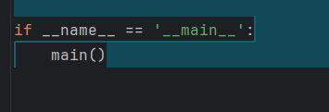
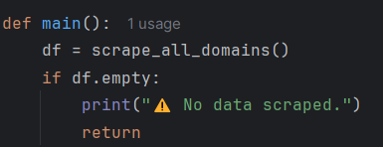
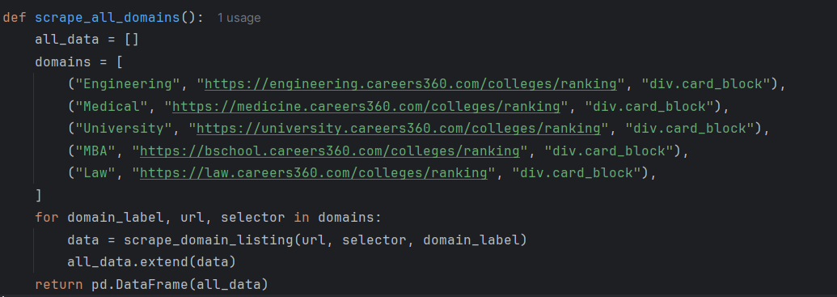
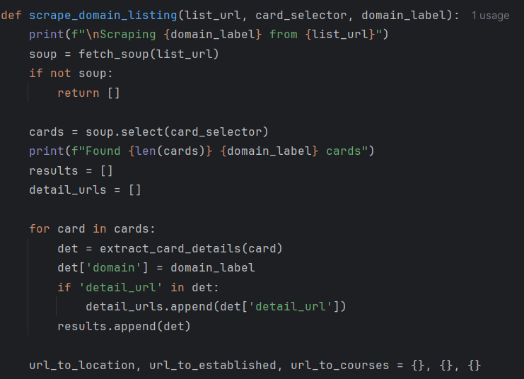

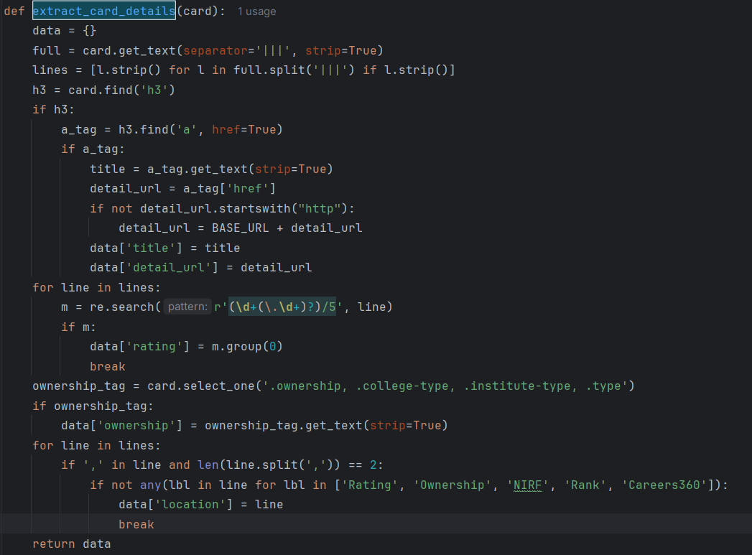
The scraper uses multithreading via ThreadPoolExecutor to fetch details faster and stores all results into a DataFrame which is finally exported as:
- Data Cleaning & Manipulation
Tool Used:
Pandas, NumPy, Regular Expressions (re)
The cleaning process ensures the dataset is ready for analysis by handling missing, inconsistent, and non-numeric values.

Steps Taken:

- Null Removal

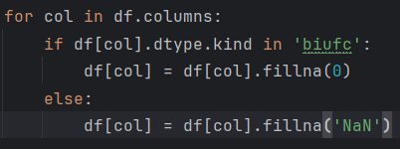

- Fee Conversion

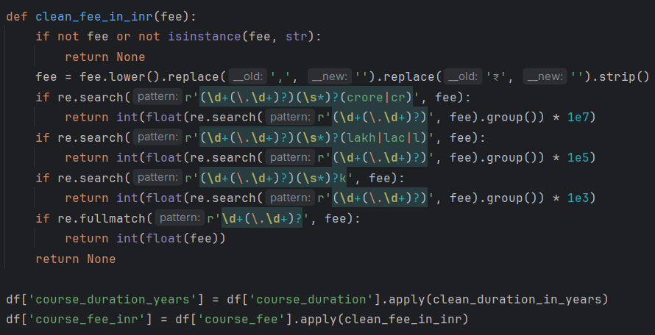

- Duration Conversion

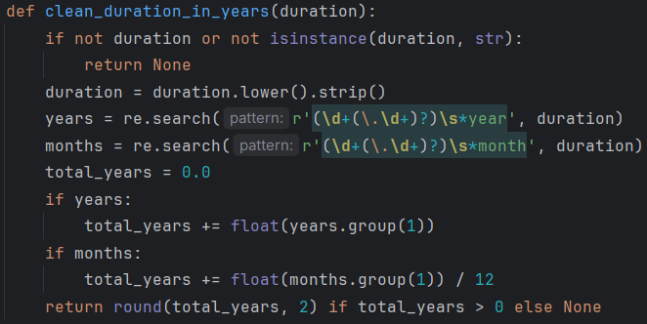

- Rating Conversion

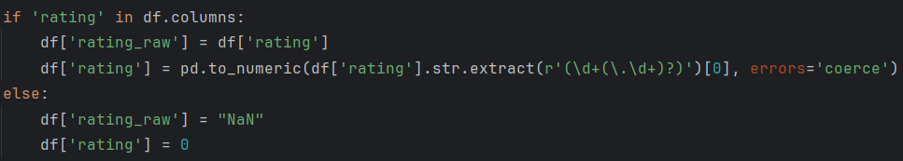

- Final Dataset
- The raw data is saved with name careers360_colleges.csv
- The cleaned data (cleaned_careers360_colleges.csv) contains columns like:
- Title, Domain, Rating, State, City, Established Year
- Course Name, Duration (Years), Fee (INR), Seats

- Visualization & Analysis
Tool Used: Python (Matplotlib), Power BI
The dataset was used to build visual insights and interactive dashboards.
Python Visualizations:
  - KPI Summary: Total Colleges, average rating, average fee.

Python Code:

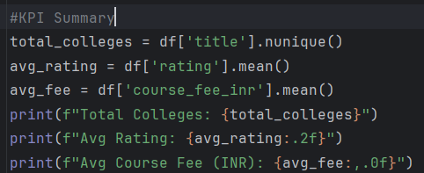

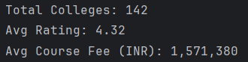

Insights:
- The dataset includes a large number of colleges across multiple Indian states, reflecting a strong higher education network.
- The average rating (3.8/5) indicates good overall quality in engineering education.
- The average course fee (₹1.2-₹1.5 lakhs per year) shows moderate affordability, with notable variations by state and ownership type.

  - Donut Chart: College distribution by domain

Python Code:

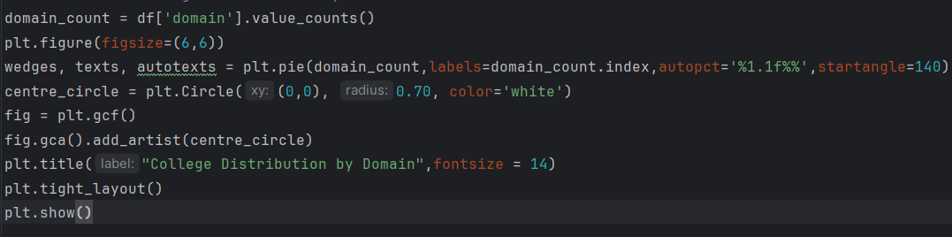
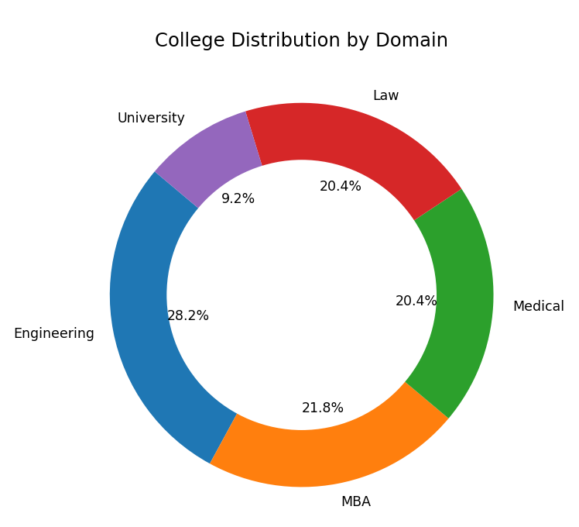
Insights:
- Engineering dominates the dataset, followed by MBA and Medical Domains.
- Smaller shares for Law and University courses highlight limited institutional presence in those areas.
- This distribution confirms that technical education remains the primary focus in India’s higher education landscape.

  - Bar Charts:
- Top 10 states by college count

Python Code:

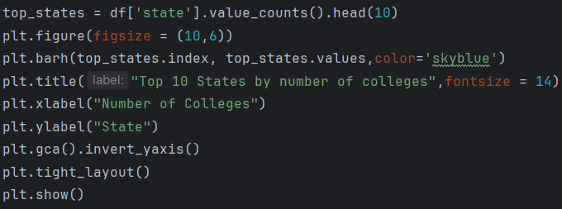

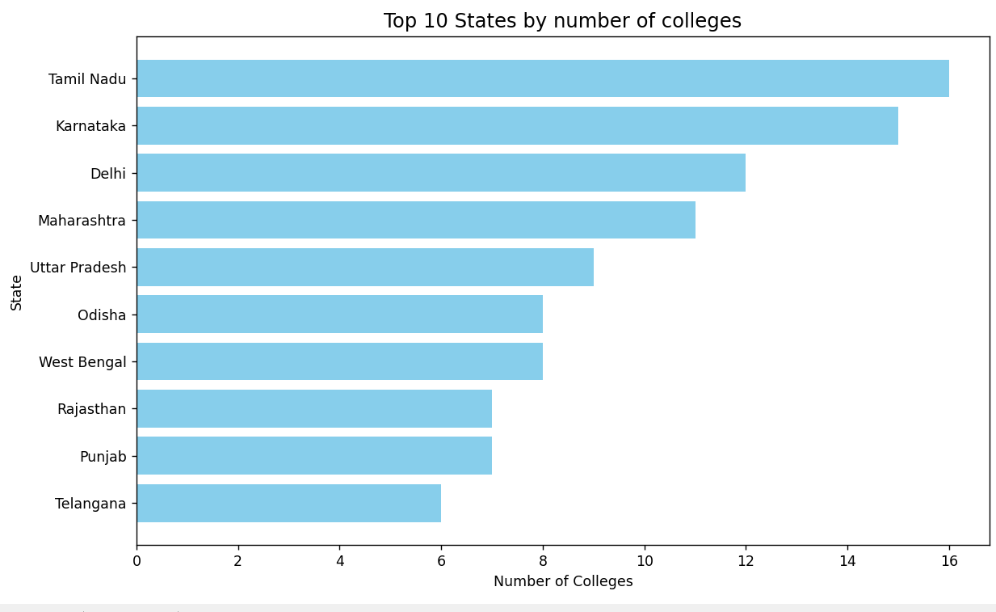
Insights:
- Maharashtra, Tamil Nadu, and Karnataka have the highest number of engineering colleges.
- States with industrial or IT clusters tend to have more colleges, supporting local workforce needs.
- The visualization emphasizes a geographical concentration of technical education opportunities in southern and western India.

- Top 10 colleges by rating

Python Code:

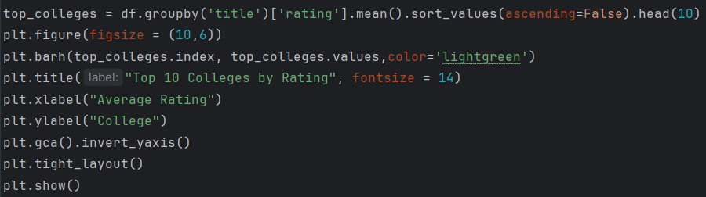

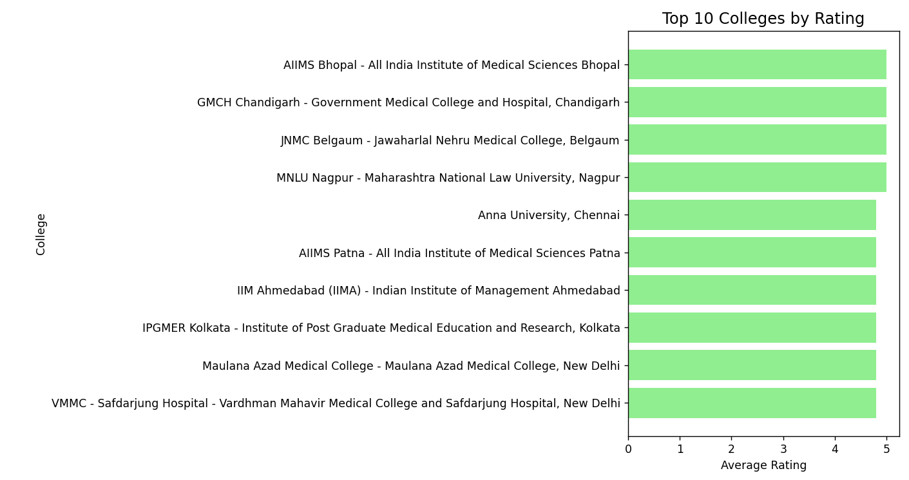
Insights:
- Highly rated colleges include top institutes like IITs, NITs, and leading private universities.
- These institutions are known for quality teaching, strong research output, and excellent placements.
- The chart helps identify benchmark colleges that set quality standards within their domains.

- Average fee by domain
Python Code:
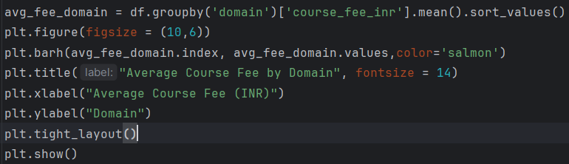
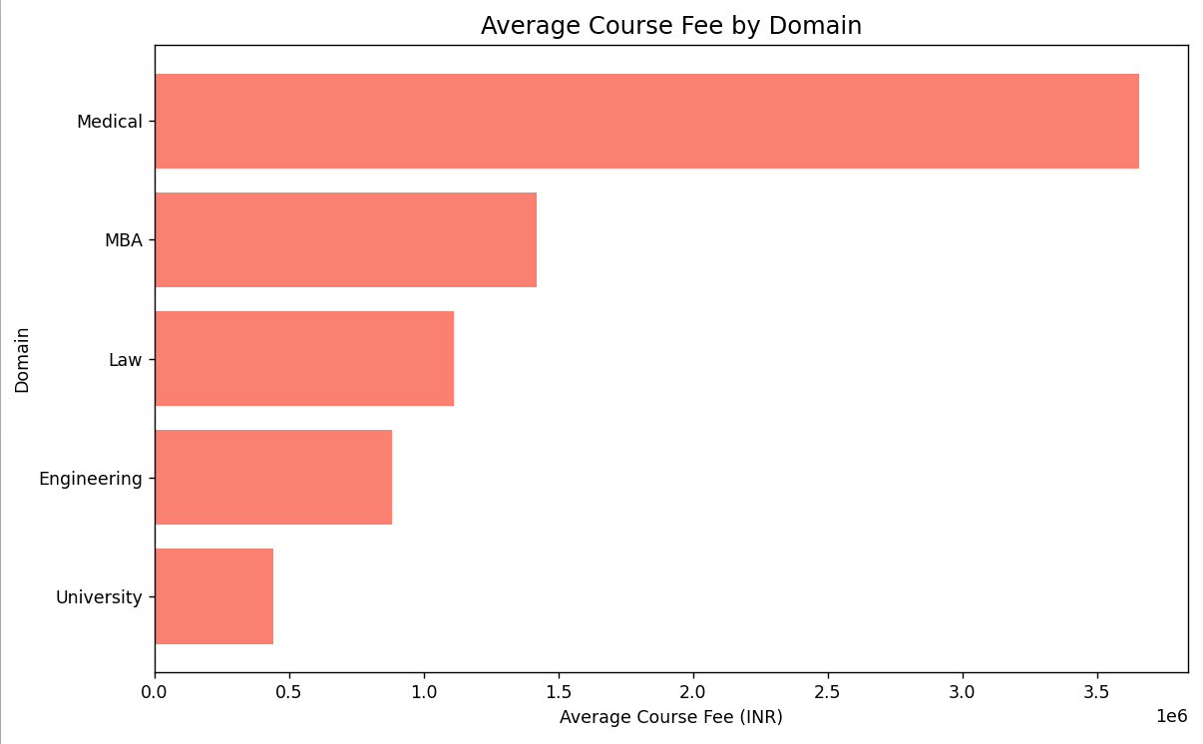

Insights:
- Medical and MBA programs have the highest average fees, often 3-5x higher than Engineering courses.
- Engineering and Law domains remain comparatively affordable for students.
- The fee differences suggest higher infrastructure and specialization costs in professional domains.

- Average rating by decade

Python Code:
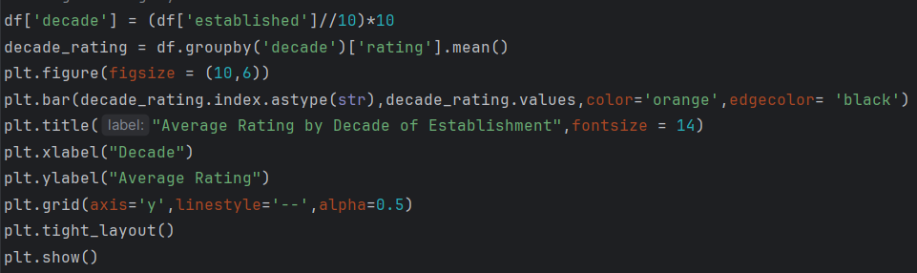
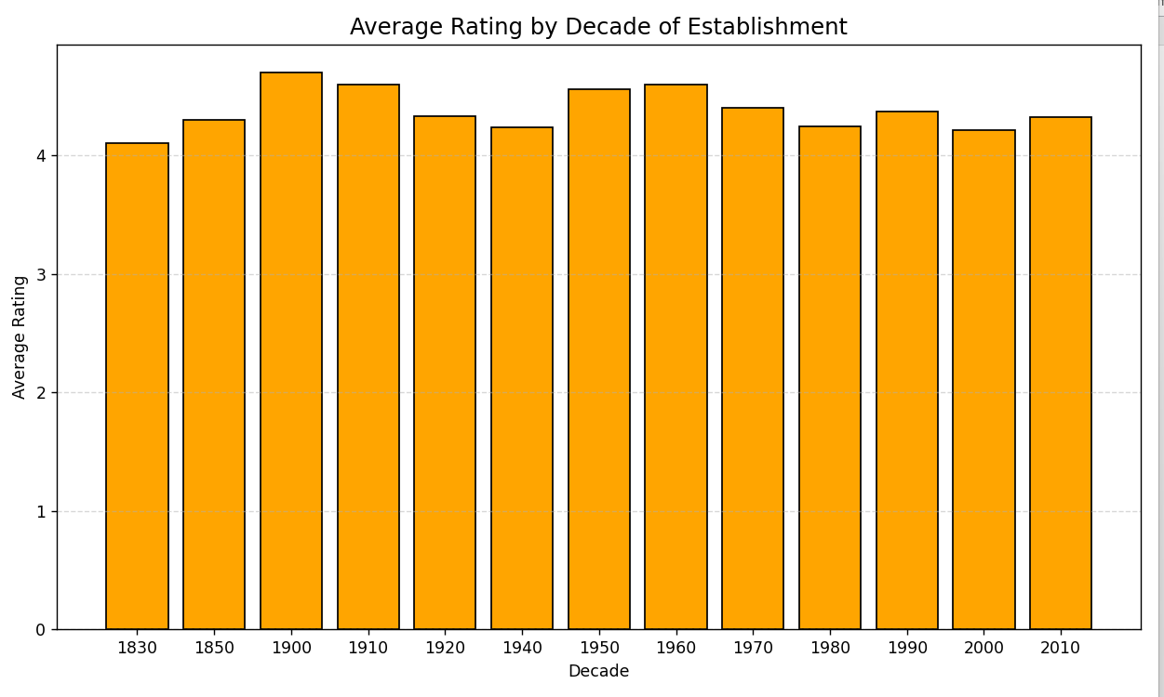

Insights:
- Colleges established in the 1990s and 2000s have the highest average ratings.
- Older institutions have better reputations due to experience, infrastructure, and alumni networks.
- Newly established colleges show moderate ratings, still building credibility over time.

- Scatter Plot: Course fee vs rating

Python Code:

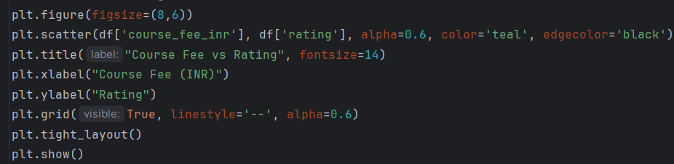
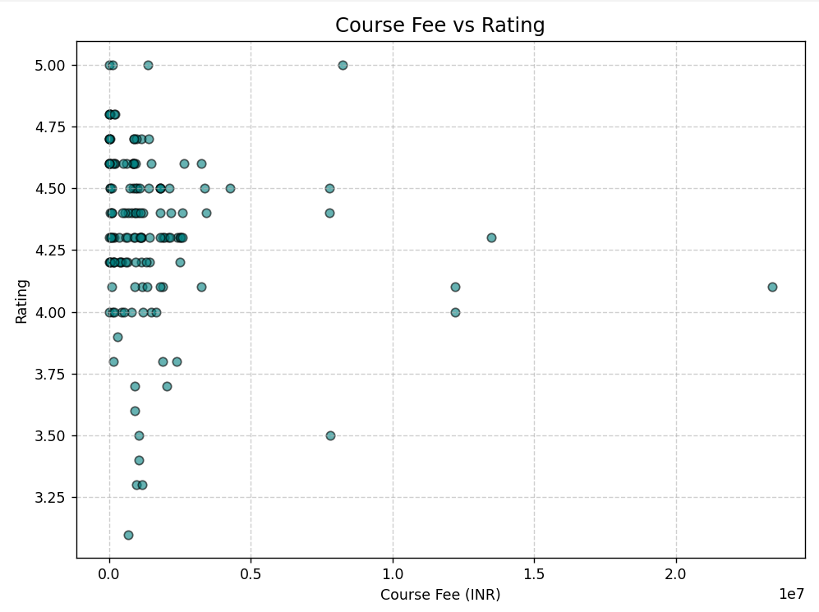

Insights:
- There is no strong correlation between course fee and college rating.
- Some low-fee government colleges achieve higher ratings, proving affordability and quality can coexist.
- High-cost private colleges don’t always guarantee superior ratings, indicating value depends on multiple factors.

- Clustered Bars: Course Count by state and domain

Python Code:
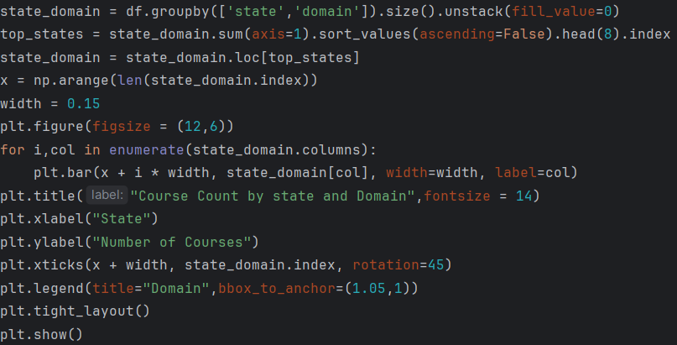

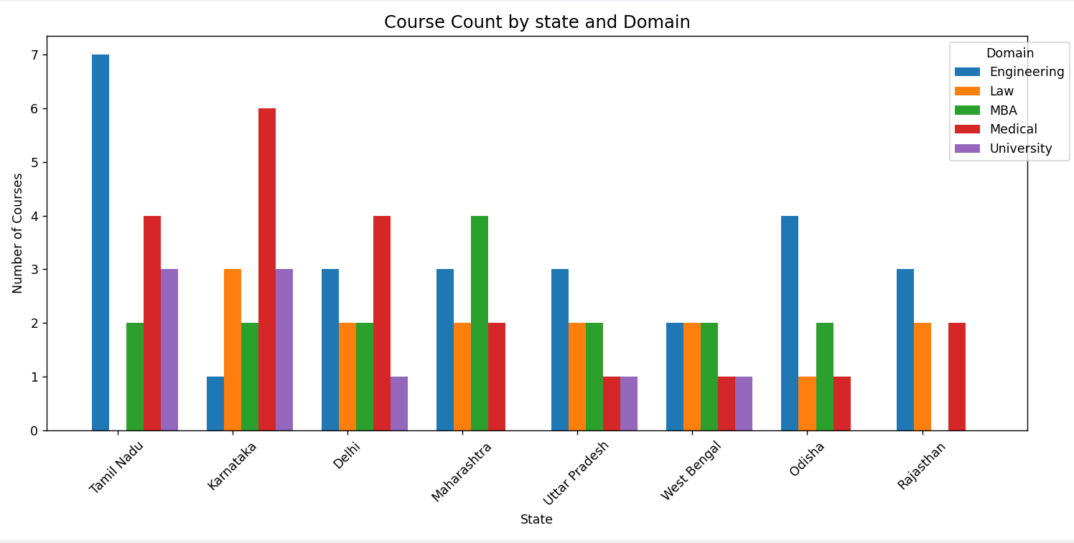

Insights:
- Maharashtra, Tamil Nadu, and Karnataka offer the widest range of courses across domains.
- The Engineering domain dominates across all states, with MBA and Medical showing regional concentration.
- This indicates regional specialization and highlights states that act as education and industry hubs.

- Line Chart: Colleges established over the years.

Python Code:

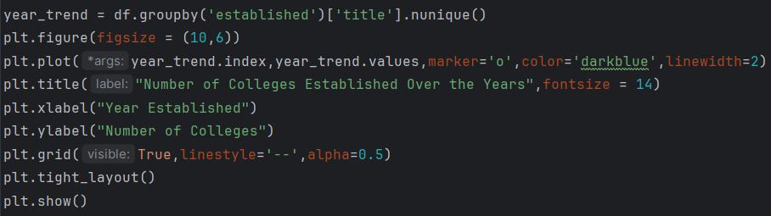

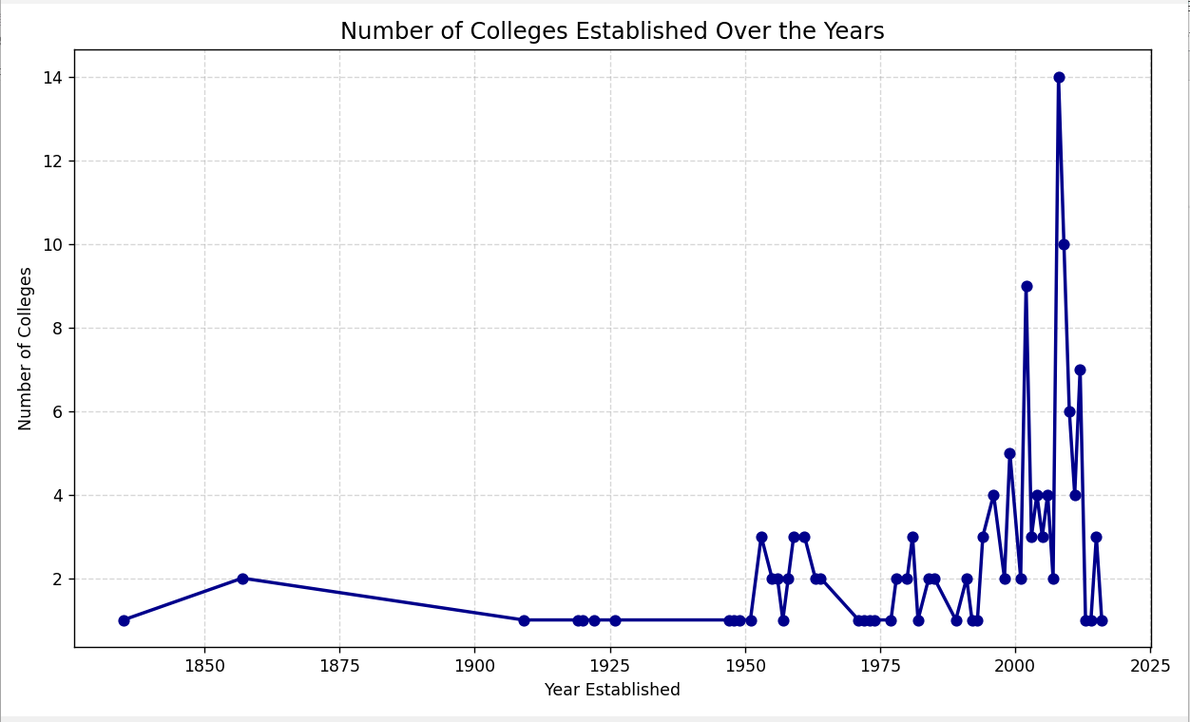

Insights:
- A consistent rise in new colleges is observed between 1980 and 2010.
- Post-2015, the number of new institutions plateaus, suggesting market saturation or stricter approvals.
- The trend reflects India’s educational expansion era followed by stabilization in recent years.

- Clustered Bar Chart: Top 10 Most expensive Courses

Python Code:

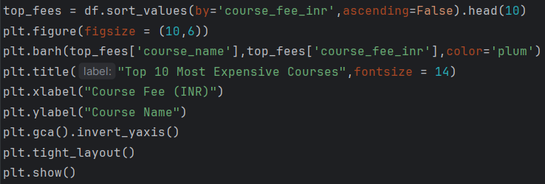

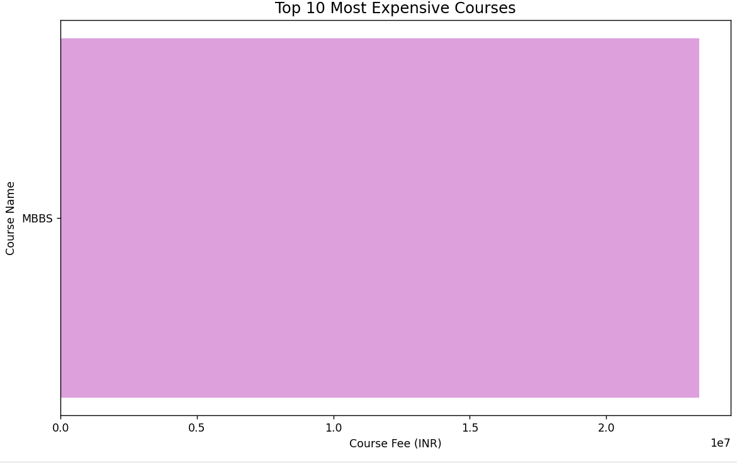

Insights:
- The most expensive programs belong mainly to MBA and Medical domains.
- Fees range from ₹10-₹20 lakhs or more, reflecting specialized or postgraduate-level programs.
- These are typically offered by private universities, highlighting a cost disparity with public institutions.

- Donut Chart: Course duration distribution

Python Code:

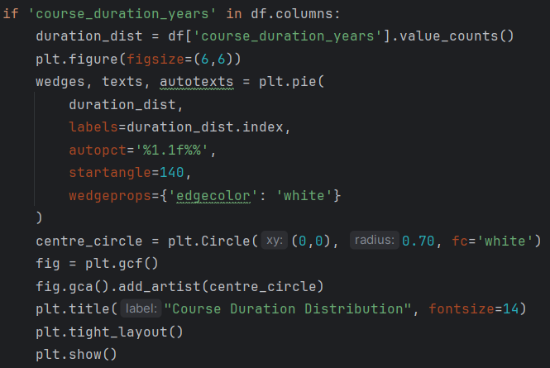

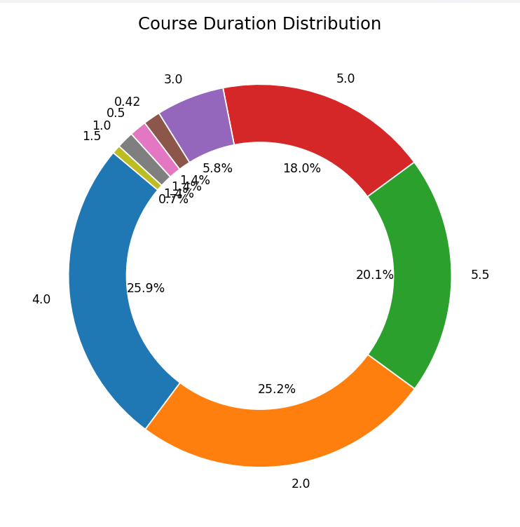
Insights:
- The majority of courses have a 4-year duration, typical for B. Tech programs.
- 2-year courses mainly represent postgraduate (M. Tech/MBA) programs.
- This shows that undergraduate education remains the most common offering in India’s college landscape.

Power BI Dashboards:
Dashboard 1:
  - KPIs: Total Colleges, Avg Rating, Avg Fee
  - Donut Chart: Colleges by Domain
  - Bar Charts: Top 10 states by College Count, Top 10 colleges by Rating
  - Filled Map: College locations by State
  - Added Slicers: State, Rating and Domain

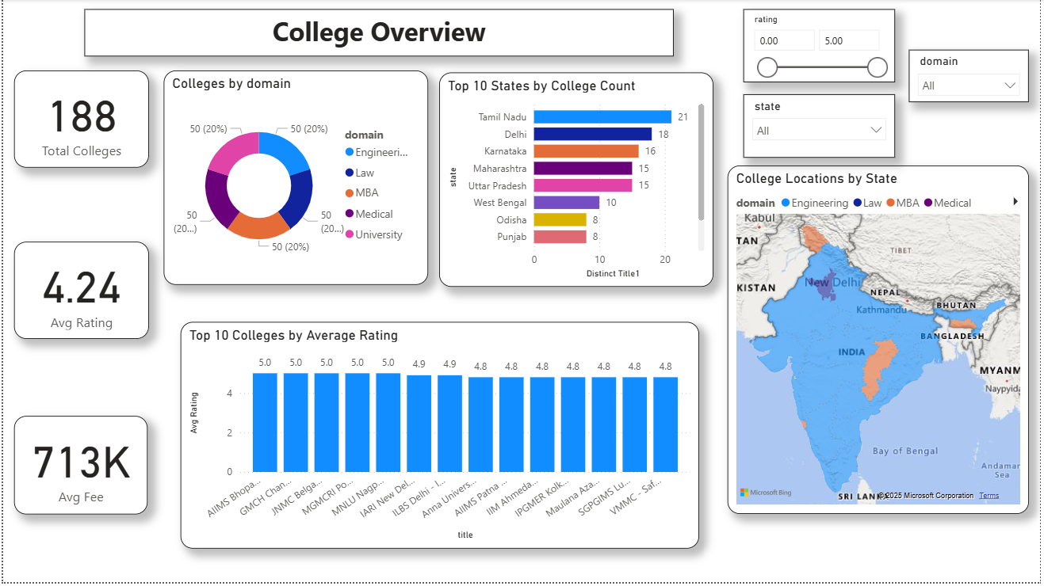

Dashboard 2:

- Table: All college details
- Bar Charts: Courses Offered by State, Avg Fee by Domain
- Scatter Chart: Fee vs Rating
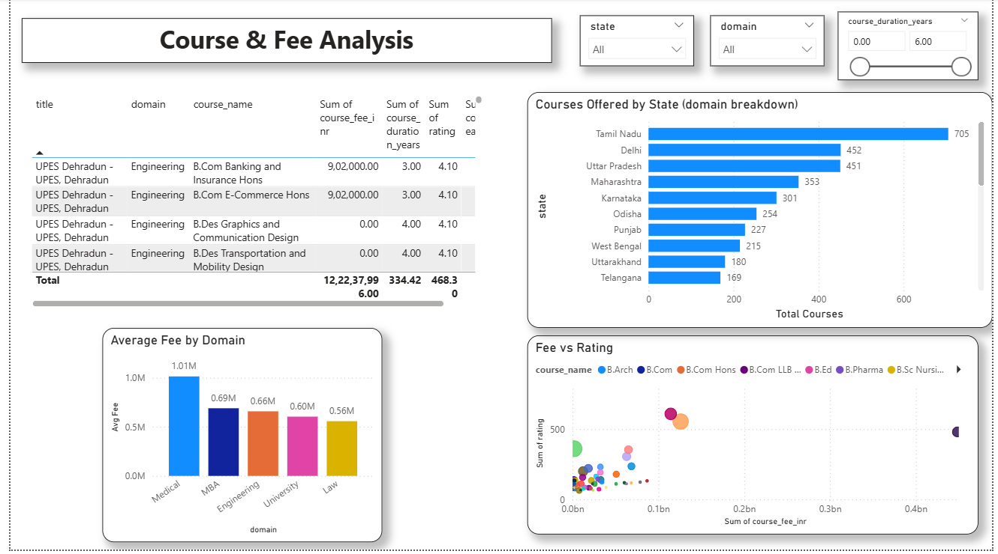

Dashboard 3:

- Bar Chart: Top 10 Most Expensive Courses
- Line Chart: Colleges Established Over Time
- Donut Chart: Course Duration Distribution
- Bar Chart: Avg Rating by Year of Establishment

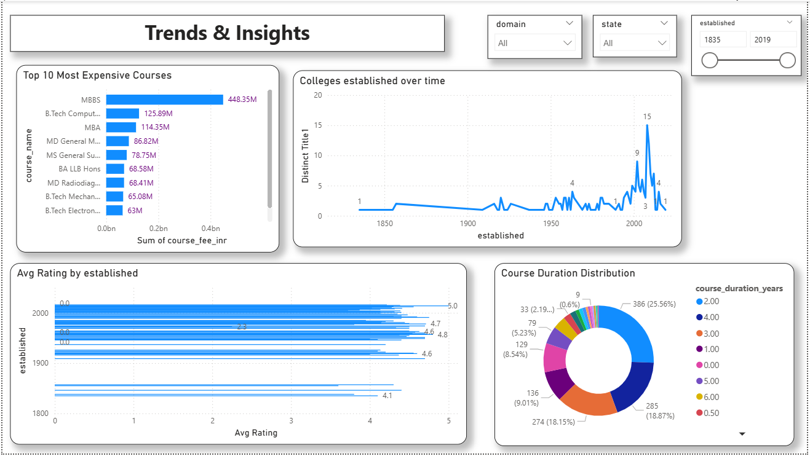

Tools Used
Category | Tools/Technologies
Programming | Python 3.x
Libraries | BeautifulSoup, Requests, Pandas, NumPy, Matplotlib, Concurrent Futures
Visualization | Power BI, Matplotlib
Data Source | Careers360.com
File Format | CSV(Processed dataset)

Results & Findings
- The dataset contained hundreds of colleges from across all states.
- Top States by College Count: Maharashtra, Tamil Nadu, Karnataka, and Uttar Pradesh.
- Average Rating: Around 3.8/5, showing good quality distribution overall.
- Average Annual Fee: Approximately ₹1.2-₹1.5 Lakhs.
- Private Colleges dominate the engineering sector.
- A gradual increase in new colleges was observed between 1990-2010, followed by a decline post-2020.
- Most courses have a duration of 4 years, aligning with the B, Tech structure.

Challenges & Limitations
- Frequent website structure changes can break scraping scripts.
- Limited access due to request blocking or rate-limiting by the source site.
- Missing or inconsistent data for some colleges.
- Power BI visuals depend on the completeness of scraped data.

Conclusion & Recommendations
The study successfully compiled and analysed comprehensive data on engineering colleges across India using Python and Power BI. The analysis offers valuable insights into the concentration, affordability, and quality of higher education institutions.
Recommendations:
- Regularly update the dataset for more accurate trends.
- Extend scraping to include placement data and infrastructure ratings.
- Integrate with APIs for automated data refresh in Power BI.

Future Scope
- Automate the web scrapping pipeline using Airflow or Cron jobs.
- Expand the dataset to include international institutions for comparison.
- Apply machine learning models for predicting college ratings or fee ranges.
- Deploy interactive dashboards publicly via Power BI Service or a web app.

